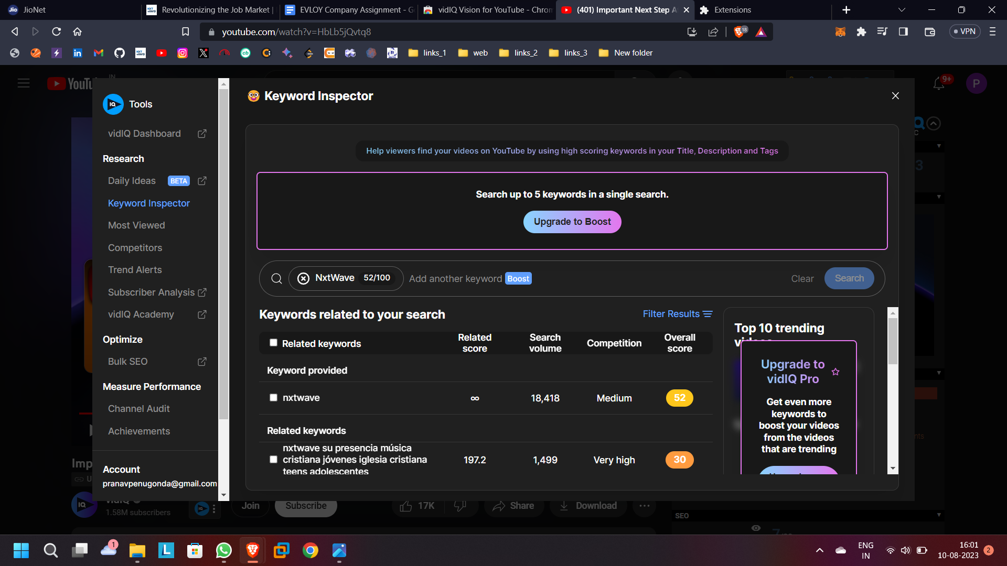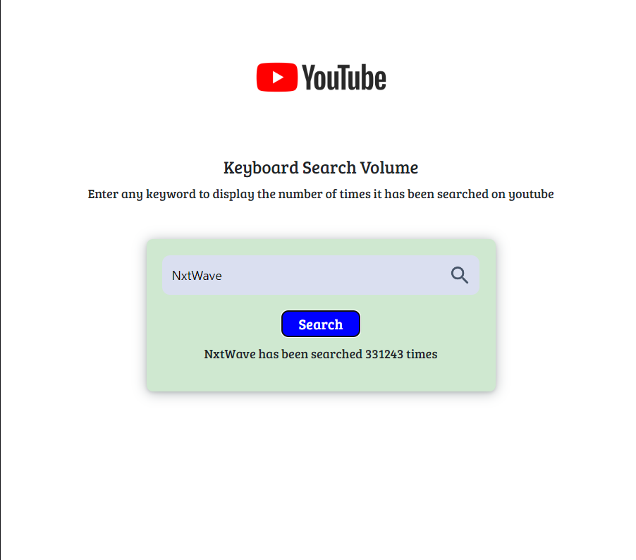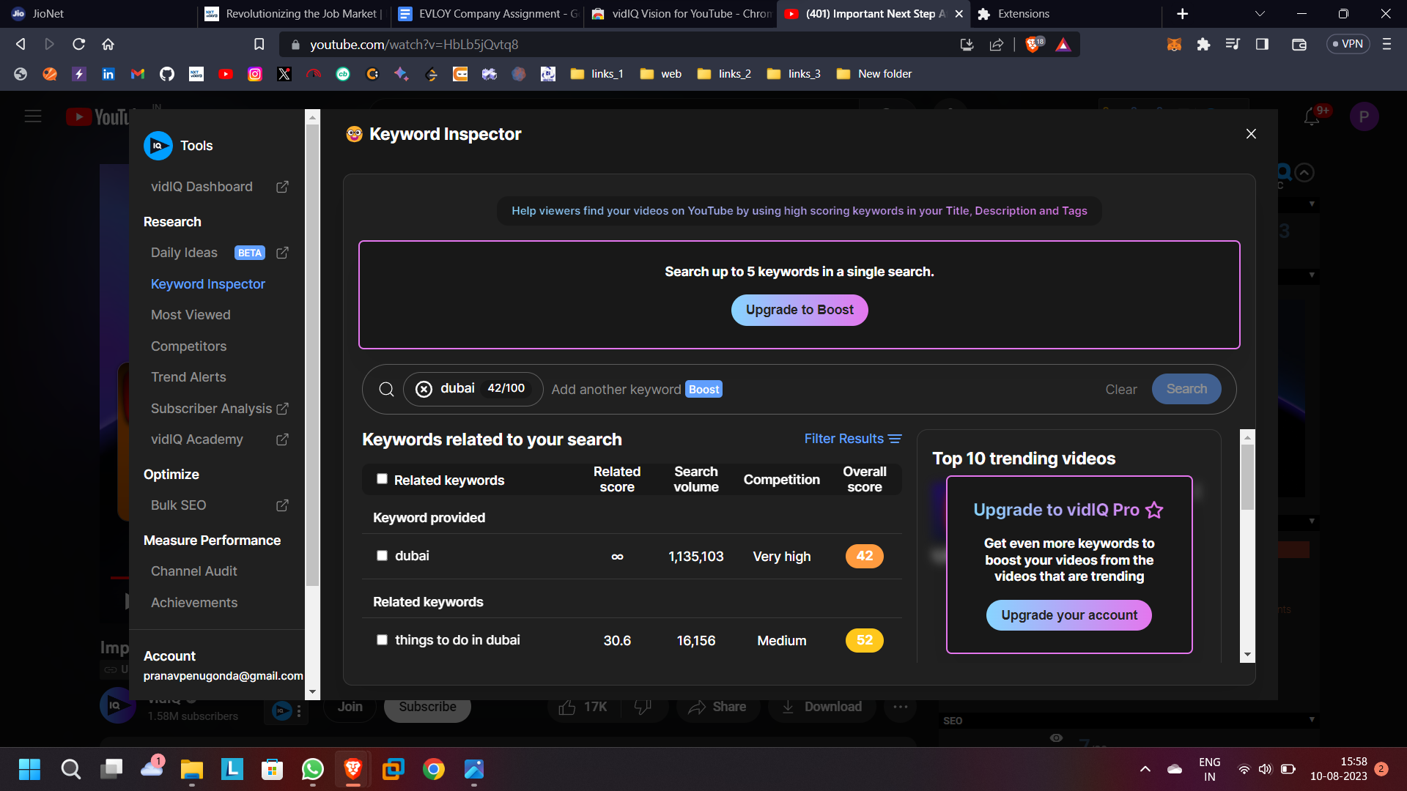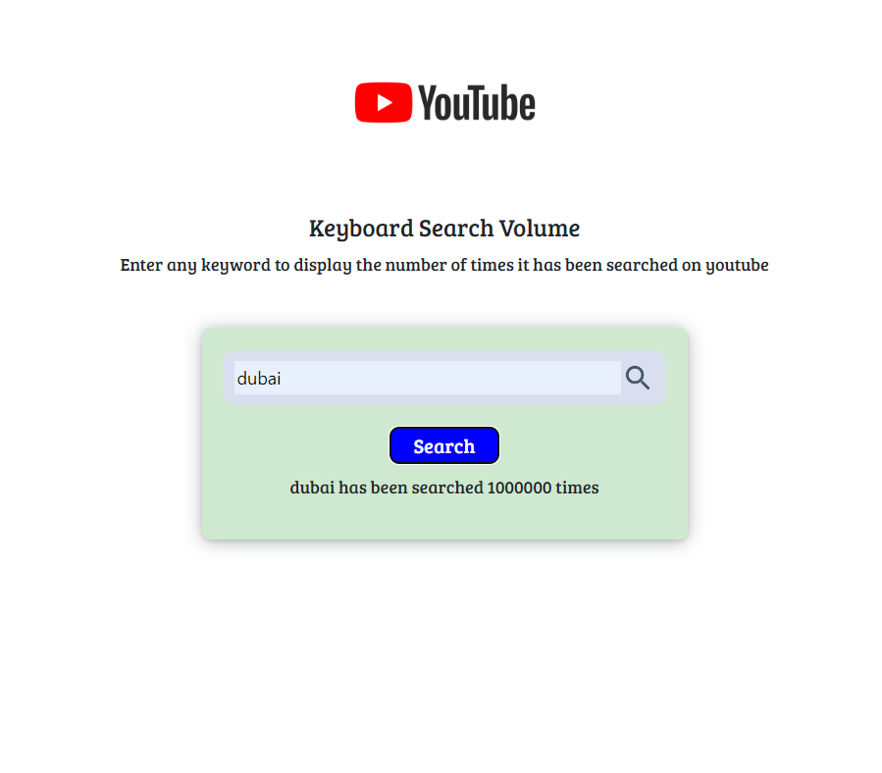  
  
  
  
These are some of the screen shots of my code outputs and vidIQ Vision for Youtube chrome extension. As it doesn’t shows the exact matches, but it shows the near values….